SIMATS ENGINEERING
CO- 2: AT – 2: Simulation Task

COURSE NAME: 5G / 6G Communication Systems
COURSE CODE: ECA5614

COURSE OUTCOME COVERED
CO: 2 - Analyse LTE and 5G wireless network architectures, including carrier aggregation, MIMO techniques, beamforming strategies, and service-based corenet work functional entities. (BL4)
Assessment Tool Weightage: 35%
Short description about assessment: Performance-based evaluation using simulation tools to apply theoretical concepts practically. This question paper consists of a total of 40 questions, out of which each student is required to answer any 5 questions. Each question carries 20 marks, and the paper carries a total of 100 marks
QUESTIONS:5 Total Marks: 100 Duration: 120 Mins
1. Simulation of LTE throughput performance under varying bandwidth, SNR, modulation order, coding rate, and user load (BL4)
2. Simulation of LTE protocol stack delay analysis under uplink traffic, downlink traffic, packet size, retransmission count, and channel quality (BL4)
3. Simulation of carrier aggregation performance in LTE-Advanced under single carrier, dual carrier, triple carrier, varying bandwidth, and SNR (BL4)
4. Simulation of LTE resource block allocation under different user numbers, scheduling methods, bandwidths, traffic load, and interference levels (BL4)
5. Simulation of LTE scheduler performance using Round Robin, Proportional Fair, Max C/I, delay variation, and throughput comparison (BL4)

Code of Conduct:
I Ch. Vishnu Vardhan (192412150) certify that this submission is my original work and that I have adhered to the guidelines specified for this assessment.
I understand that any violation of academic integrity rules will result in disciplinary action.

Signature of the student:
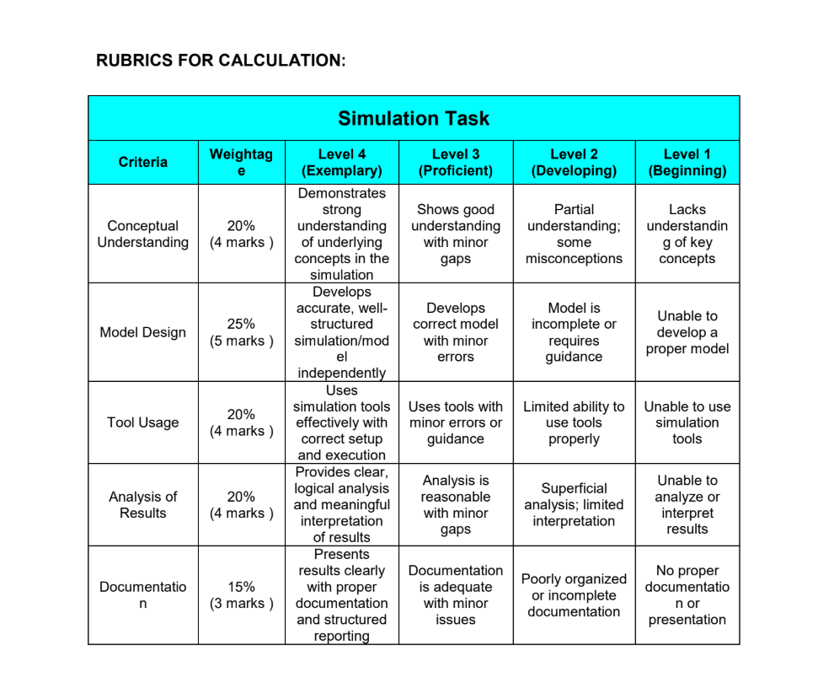

ECA5614 - CO2 AT2 - Simulation Task
Name:- Ch. Vishnu Vardhan
Reg no:-192412150

- LTE Throughput Performance Simulation
Objective:
To evaluate LTE throughput performance by varying the Signal-to-Noise Ratio (SNR) under different modulation schemes.
Matlab Code:
clc;
clear;
close all;
SNR = 0:2:30;
BW = 20; % MHz
coding = 3/4;
QPSK = BW*(2*coding).*log2(1+10.^(SNR/10))/10;
QAM16 = BW*(4*coding).*log2(1+10.^(SNR/10))/10;
QAM64 = BW*(6*coding).*log2(1+10.^(SNR/10))/10;
figure
subplot(2,1,1)
plot(SNR,QPSK,'-o','LineWidth',2)
hold on
plot(SNR,QAM16,'-s','LineWidth',2)
plot(SNR,QAM64,'-^','LineWidth',2)
grid on
xlabel('SNR (dB)')
ylabel('Throughput (Mbps)')
title('LTE Throughput vs SNR')
legend('QPSK','16-QAM','64-QAM')
subplot(2,1,2)
plot(SNR,QAM64-QPSK,'r-*','LineWidth',2)
grid on
xlabel('SNR (dB)')
ylabel('Throughput Gain (Mbps)')
title('Throughput Gain using Higher Modulation')
OUTPUT: 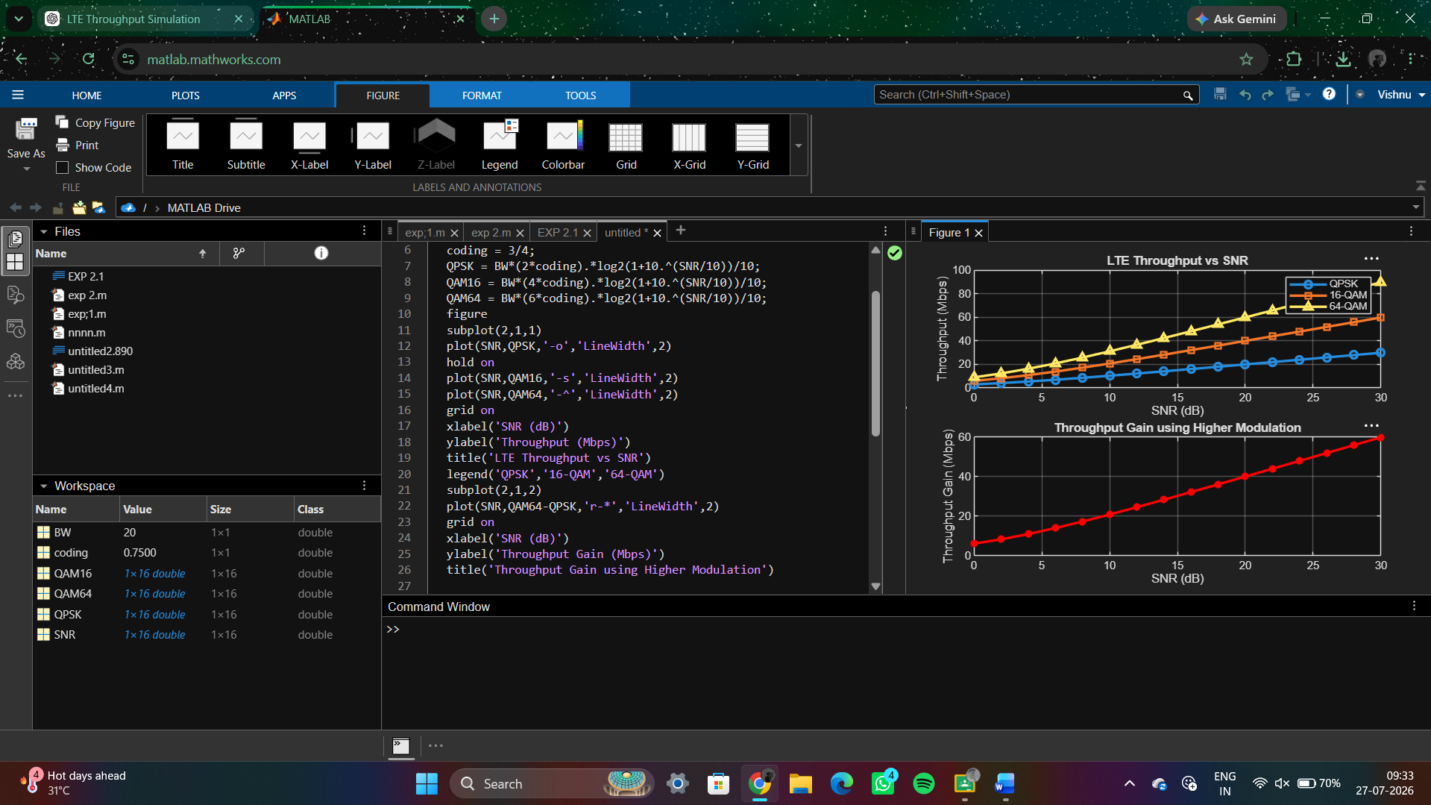

2.Simulation of LTE Protocol Stack Delay Analysis
Objective:
To analyse LTE protocol stack delay under varying uplink and downlink traffic conditions.
Matlab Code:
clc;
clear;
close all;
% Traffic Load (Mbps)
traffic = 10:10:100;
% Delay Models (ms)
uplink_delay = 4 + 0.08*traffic;
downlink_delay = 3 + 0.06*traffic;
disp('Traffic UL Delay DL Delay')
disp([traffic' uplink_delay' downlink_delay'])
figure
subplot(2,1,1)
plot(traffic,uplink_delay,'-o','LineWidth',2)
hold on
plot(traffic,downlink_delay,'-s','LineWidth',2)
grid on
xlabel('Traffic Load (Mbps)')
ylabel('Protocol Stack Delay (ms)')
title('LTE Delay under UL and DL Traffic')
legend('Uplink','Downlink')
subplot(2,1,2)
plot(traffic,uplink_delay-downlink_delay,'r-*','LineWidth',2)
grid on
xlabel('Traffic Load (Mbps)')
ylabel('Delay Difference (ms)')
title('Uplink vs Downlink Delay Difference')
OUTPUT:
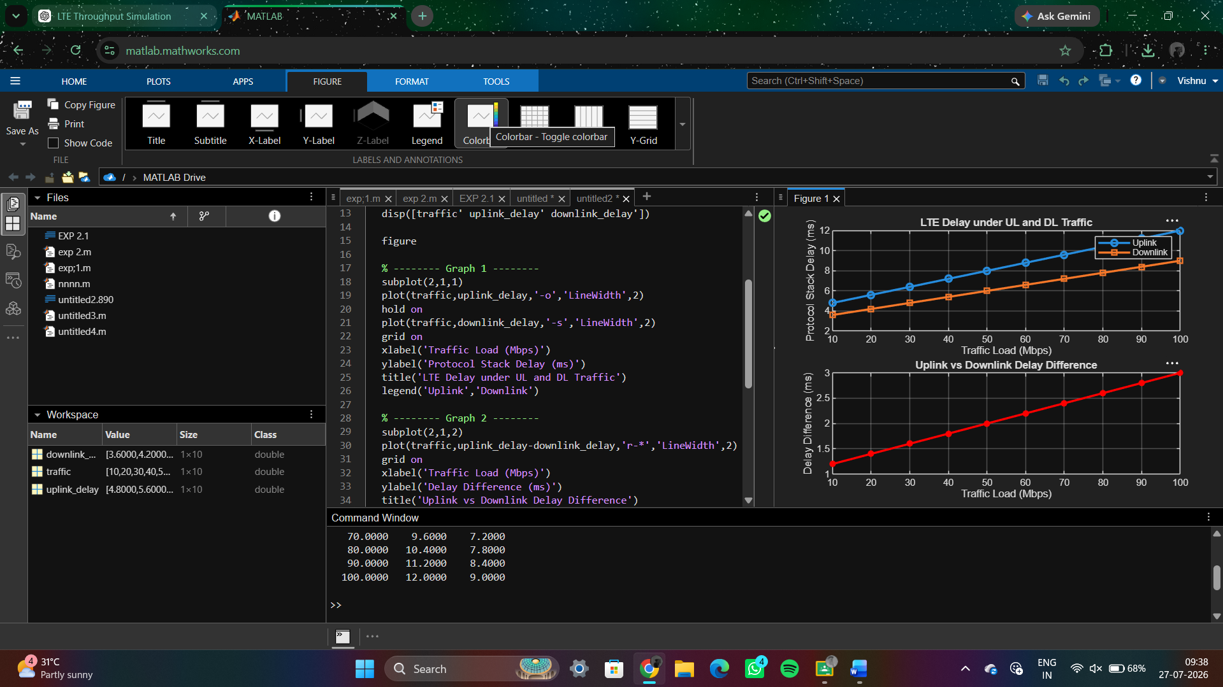

3. Simulation of Carrier Aggregation Performance in LTE-Advanced

Objective:
3.To calculate the User Throughput (Mbps) based on allocated resource blocks and modulation efficiency in the OFDMA system.
Matlab Code:
clc;
clear;
close all;
% Carrier Aggregation Modes
carriers = [1 2 3];
% Bandwidth per Carrier (MHz)
BW = 20;
% Total Throughput (Mbps)
throughput = carriers * BW * 5;
disp('Carrier Throughput(Mbps)')
disp([carriers' throughput'])
figure
subplot(2,1,1)
bar(carriers,throughput)
grid on
xlabel('Number of Aggregated Carriers')
ylabel('Throughput (Mbps)')
title('Carrier Aggregation Throughput')
% -------- Graph 2 --------
subplot(2,1,2)
plot(carriers,throughput,'-o','LineWidth',2)
grid on
xlabel('Number of Aggregated Carriers')
ylabel('Throughput (Mbps)')
title('Throughput Improvement with Carrier Aggregation')
OUTPUT: 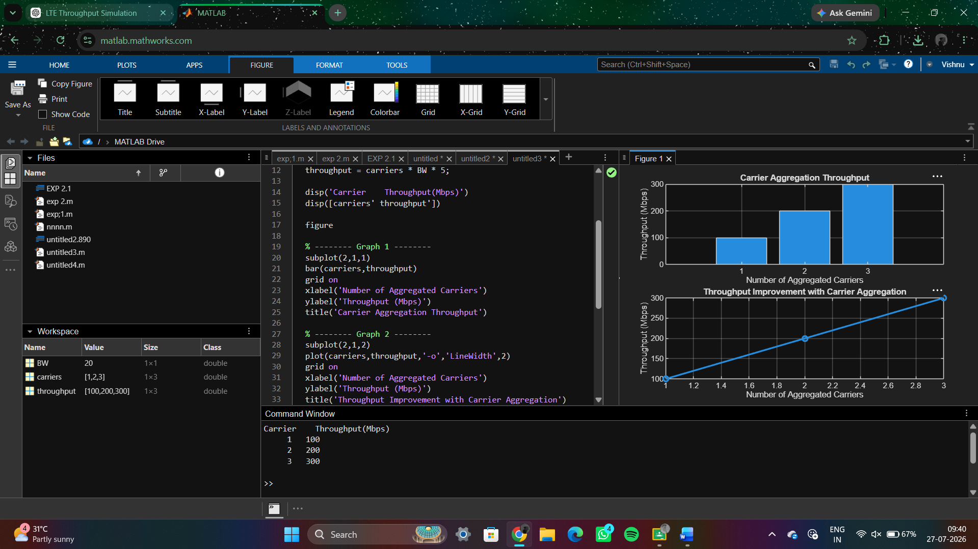

4. Simulation of LTE Resource Block Allocation
Objective:
To analyse LTE Resource Block (RB) allocation under different numbers of users.
Matlab Code:
clc;
clear;
close all;
% Total Resource Blocks
total_RB = 100;
% Number of Users
users = [5 10 20 25 50];
% Equal RB Allocation
RB_per_user = total_RB ./ users;
disp('Users RB per User')
disp([users' RB_per_user'])
figure
% -------- Graph 1 --------
subplot(2,1,1)
plot(users,RB_per_user,'-o','LineWidth',2)
grid on
xlabel('Number of Users')
ylabel('Resource Blocks per User')
title('User Count vs RB Allocation')
% -------- Graph 2 --------
subplot(2,1,2)
bar(users,RB_per_user)
grid on
xlabel('Number of Users')
ylabel('Resource Blocks per User')
title('RB Allocation Comparison')
OUTPUT:
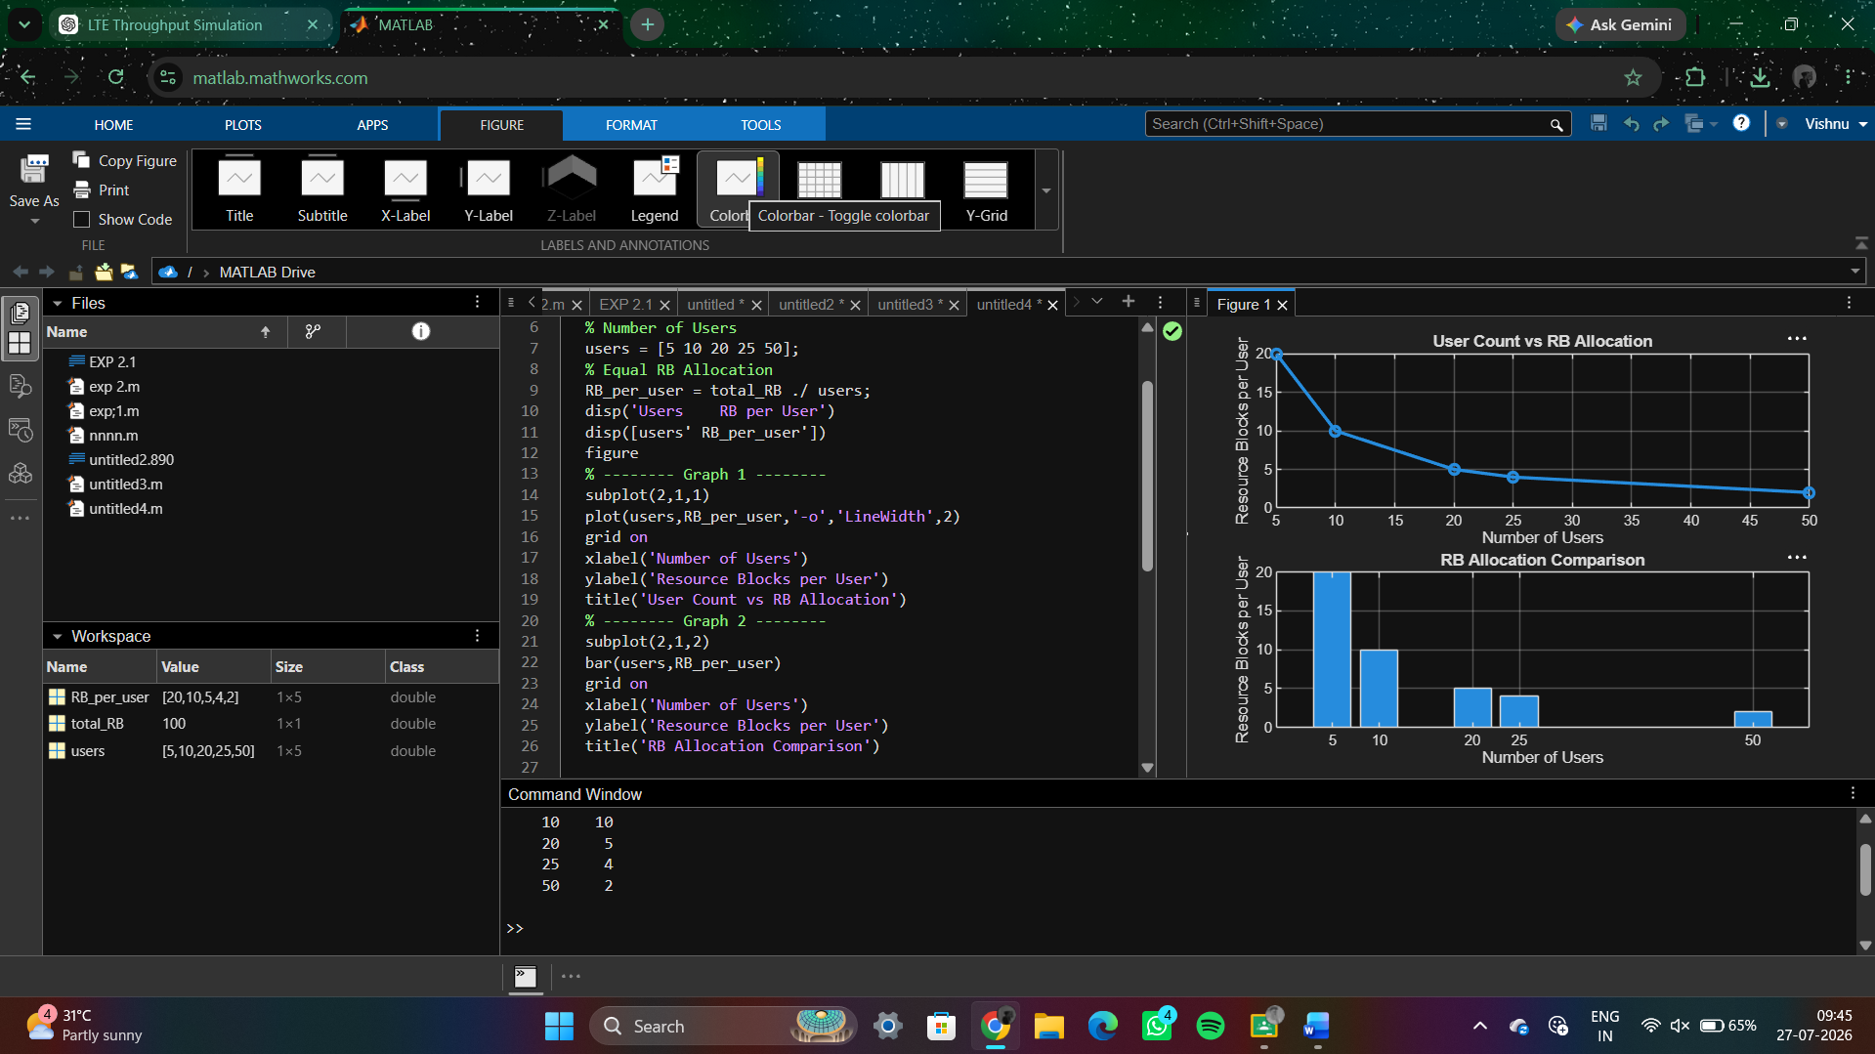

5. Simulation of LTE Scheduler Performance
Objective:
To analyse LTE scheduler performance using Round Robin (RR), Proportional Fair (PF), and Max C/I scheduling algorithms.
Matlab Code:
clc;
clear;
close all;
% Scheduling Algorithms
scheduler = {'RR','PF','Max C/I'};
% Throughput (Mbps)
throughput = [55 72 90];
figure
% -------- Graph 1 --------
subplot(2,1,1)
bar(throughput)
set(gca,'XTickLabel',scheduler)
grid on
xlabel('Scheduling Algorithm')
ylabel('Throughput (Mbps)')
title('Scheduler Throughput Comparison')
% -------- Graph 2 --------
subplot(2,1,2)
plot(1:3,throughput,'-o','LineWidth',2)
set(gca,'XTick',[1 2 3])
set(gca,'XTickLabel',scheduler)
grid on
xlabel('Scheduling Algorithm')
ylabel('Throughput (Mbps)')
title('Scheduler Performance')
OUTPUT: 